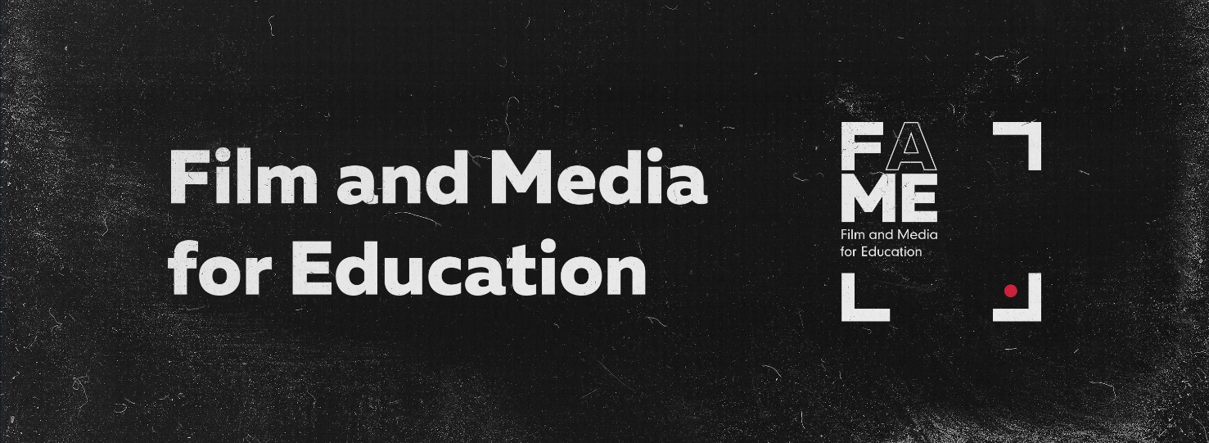

|  |  |
| --- | --- |
| **Name / Surname** |  |
| **Affiliated Institution** |  |
| **City/ Country** |  |
| **Position** |  |
| **Teaching Subjects** |  |
| **Phone number** |  |
| **E-mail** |  |

**Shortly describe, why taking part in this conference would be important for you and how are you planning on promoting film and media literacy for education in your community.** *(up to 300 words)*

|  |
| --- |
|  |